**School of Computer Science Engineering & Information Science**

**Analysis On Unemployment In India Report**

**Course Title: Data Analysis And Visualization**

**Course Code:** CSE2015

**Date of Submission: 17/05/2024**

**Submitted By:**

|  |  |  |  |
| --- | --- | --- | --- |
| **Sl.No** | **Roll Number** | **Name** | **Signature** |
| **1** | **20211ISD0027** | **K PAVAN KUMAR** |  |
| **2** | **20211ISD0033** | **CHANDAN BN** |  |
| **3** | **20211ISD0036** | **BANDI ANIL KUMAR** |  |

Abstract

Unemployment is a persistent problem in India, with significant social and economic consequences. This paper provides an overview of the current state of unemployment in India, including the latest unemployment rate and the factors contributing to this issue. The paper also examines the various measures that the Indian government has taken to address unemployment, such as skill development programs and the promotion of entrepreneurship and foreign investment. Despite these efforts, the challenge of creating adequate job opportunities for the growing population of India remains significant. This paper highlights the need for continued efforts to address unemployment in India and suggests potential solutions for improving the situation.

Keywords: - Unemployment, Difficulties, States, Machine Learning (ML), India.

INTRODUCTION

Unemployment in India refers to the situation where a significant portion of the population who are willing and able to work are without a job. It is a persistent problem that has various

social and economic consequences, including poverty, crime, and inequality. According to the latest available data from the National Statistical Office (NSO), the unemployment rate in India was 6.1% in 2018-2019. However, this figure does not account for

underemployment or people who are working in jobs that are not commensurate with their skills and qualifications. The factors contributing to unemployment in India are complex and multifaceted. One of the primary reasons is the lack of sufficient job opportunities in the country. The Indian economy has not been able to create enough jobs to absorb the growing workforce. As per a report by

the International Labour Organization (ILO), India needs to create approximately 90 million

non-farm jobs by 2030 to keep up with the growing workforce.

Here are some key factors that have contributed to unemployment in India:

1. Lack of sufficient job opportunities

2. Low levels of education and skill development

3. Mismatch between the skills required by employers and those possessed by job seekers

4. Impact of automation and technology on the job market

5. Slow economic growth

6. Poor infrastructure and inadequate support for small and medium-sized enterprises

7. Gender discrimination and unequal access to opportunities

8. Limited availability of formal sector jobs in rural areas

9. Seasonal and cyclical nature of employment in certain industries

10. Inadequate labour laws and regulations

OBJECTIVES

The objective of this research paper is to analyse the data on unemployment in order to gain a

deeper understanding of the extent and nature of unemployment in India. By examining various

sources of data and employing statistical analysis, this paper aims to provide insights into the

factors contributing to unemployment, the types of unemployment prevalent in the country,

and the socio-economic consequences of unemployment. Through this analysis, we hope to

contribute to a better understanding of this critical issue and inform policies and interventions

aimed at reducing unemployment and promoting inclusive economic growth in India.

METHODOLOGIES

in this research paper, we are utilizing advanced analytical techniques, including Machine Learning algorithms, to analyze the data on unemployment in India. By employing these methods, we aim to identify patterns, trends, and relationships in the data that may not be apparent through traditional statistical analysis. Through this approach, we hope to gain a more nuanced and comprehensive understanding of the complexities of unemployment in India, which can inform the development of more effective policies and interventions to address this critical issue.

PHASES OF ANALYSIS

This research paper is focused on analysing the impact of the COVID-19 pandemic and associated lockdowns on unemployment in India. To do so, we are considering two distinct phases: the period before the lockdowns were implemented, and the period after. By comparing and contrasting the trends and patterns in unemployment data across these two phases, we aim to identify the specific impacts of the pandemic and lockdowns on the labour market in India. Through this analysis, we hope to provide insights into the immediate and long-term consequences of the pandemic on employment in India, and inform policy interventions aimed at mitigating the impacts of this crisis on the country's workforce.

PHASES OF ANALYSIS

This research paper is focused on analysing the impact of the COVID-19 pandemic and associated lockdowns on unemployment in India. To do so, we are considering two distinct phases: the period before the lockdowns were implemented, and the period after. By comparing and contrasting the trends and patterns in unemployment data across these two phases, we aim to identify the specific impacts of the pandemic and lockdowns on the labour market in India. Through this analysis, we hope to provide insights into the immediate and long-term consequences of the pandemic on employment in India, and inform policy interventions aimed at mitigating the impacts of this crisis on the country's workforce.

Context

The story behind this dataset is how lock-down affects employment opportunities and how the unemployment rate increases during the Covid-19.

Content This dataset contains the unemployment rate of all the states in India

Region = states in India

Date = date which the unemployment rate observed

Frequency = measuring frequency (Monthly)

Estimated Unemployment Rate (%) = percentage of people unemployed in each state of India

Estimated Employed = percentage of people employed

Estimated Labour Participation Rate (%) = labour force participation rate by dividing the number of people actively participating in the labour force by the total number of people eligible to participate in the labour force

Dataset Describe

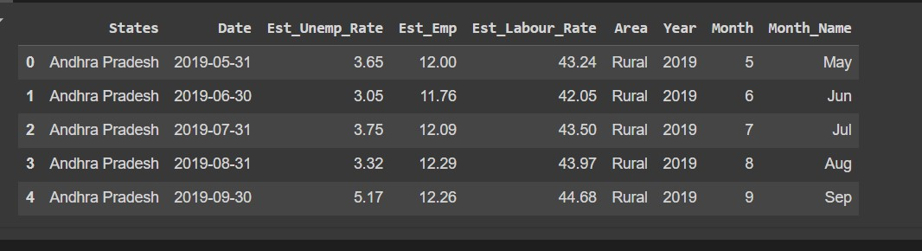

State-wise Analysis: Unemployment Rate:

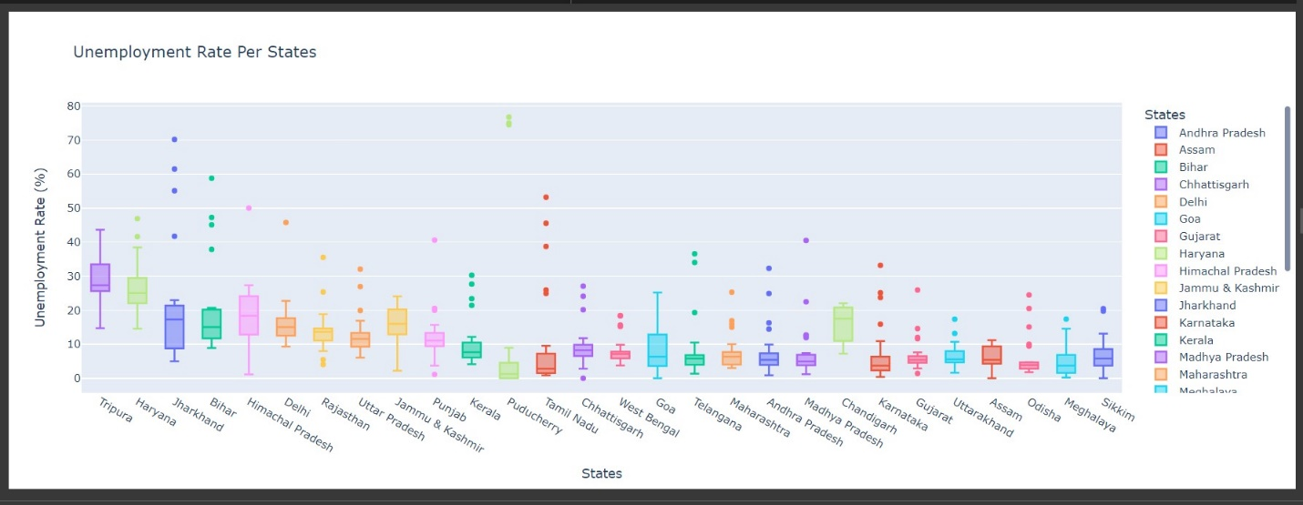

Average Unemployment Rate:

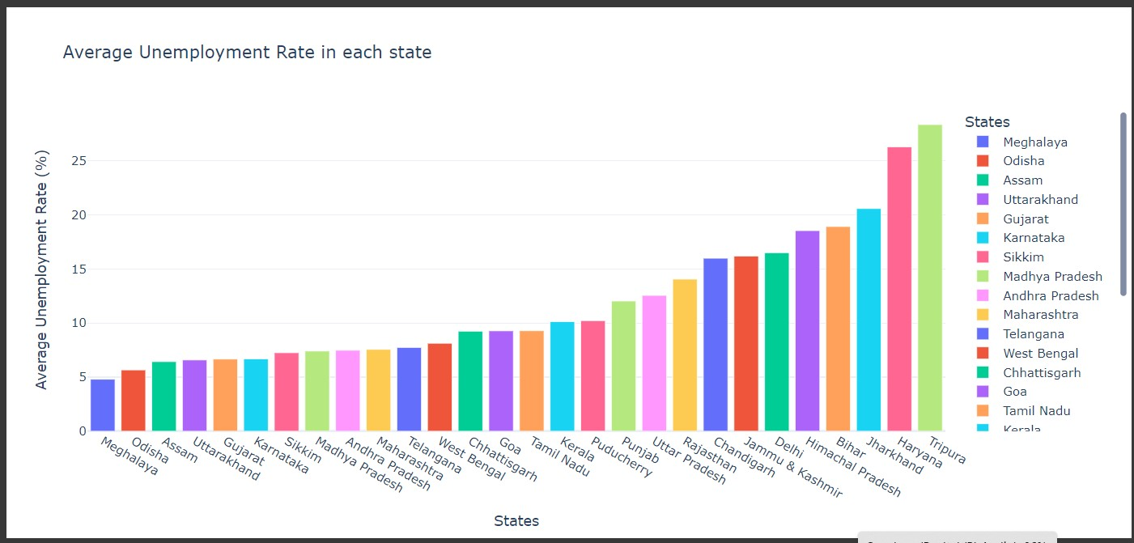

Sunburst Plot for Unemployment Diagram in every region within state:

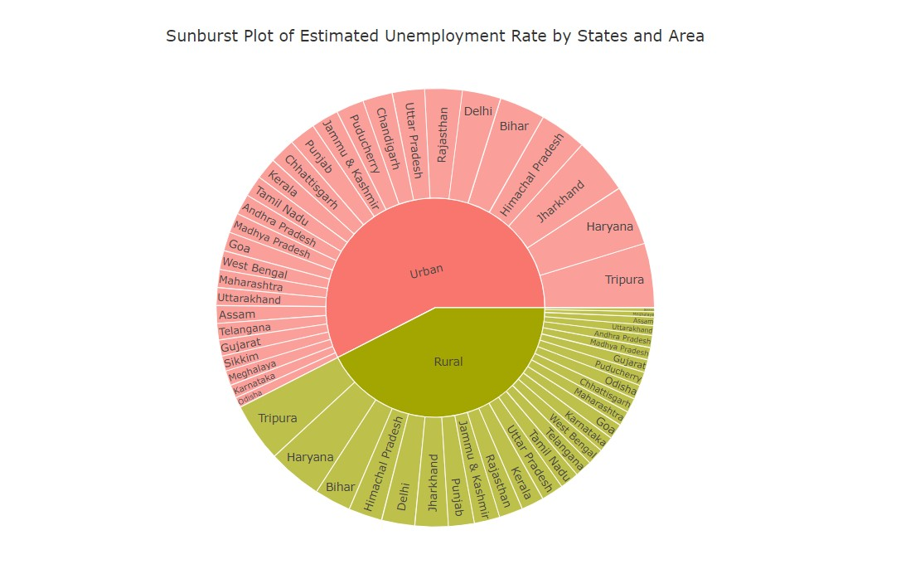

Scatter Plot:

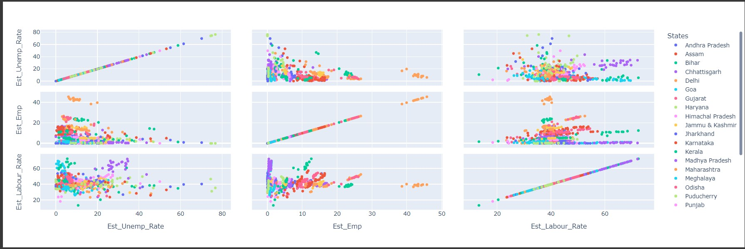

Correlation Matrix

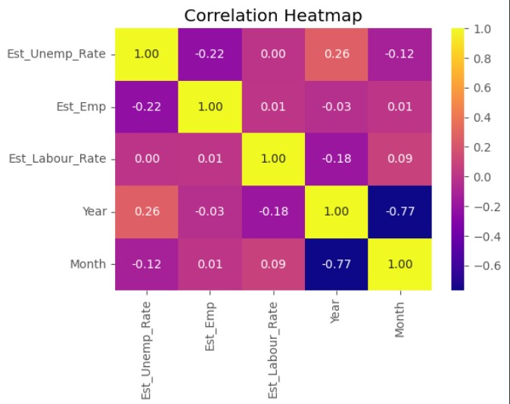

Bar Plot of Average Labour Rate by States

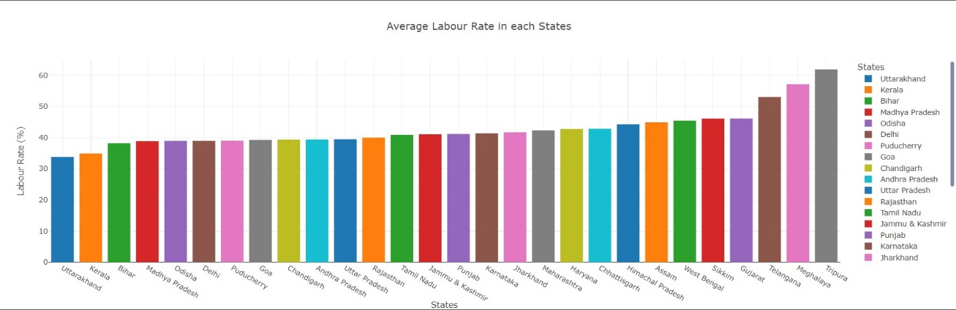

Scatter Plot Labour Rate by States

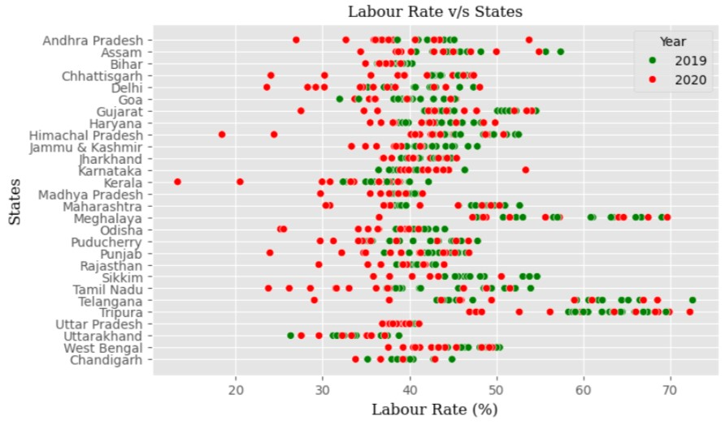

Analysing the Labour Rate Column with Violin Plot

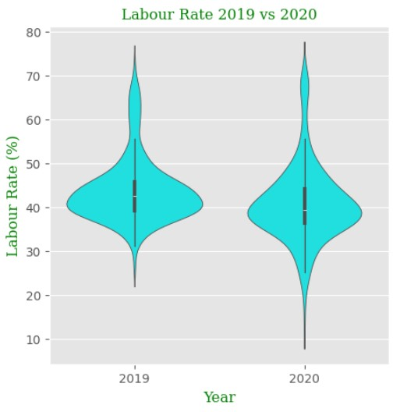

Pie Chart for Rural And Urban Count

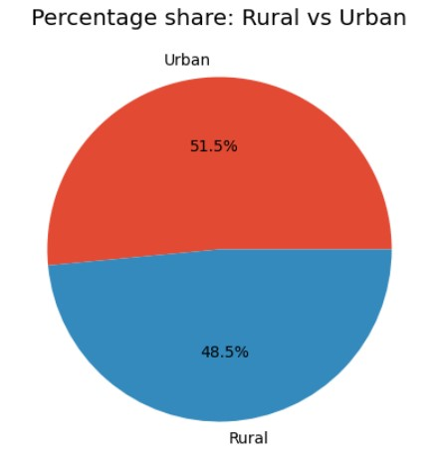

Descriptive Statistics

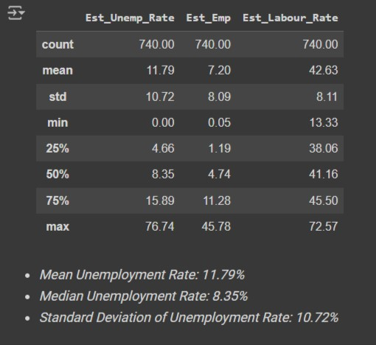

LIMITATIONS

The data used here is just a sample, with this we cannot hold enough strength for full functionally corrected analysis. This is just a sample of whole millions of data within populations.

• Access to advanced databases is restricted owing to lack of subscription;

• Survey data is not the most dependable source for undertaking statistical analysis;

• Recurrent inaccuracies in reported data due to nulls and blanks;

• Inadequate equipment for processing massive amounts of data

• Inadequate availability of all variables in the databases

TOOLS USED

1. Python

2. Google Collab

3. Kaggle

4. UCI Datasets Repository

5. Various Research Papers

CONCLUSION

In conclusion, this research paper has utilized advanced analytical techniques, including machine learning algorithms, to analyze the data on unemployment in India. By considering two distinct phases - before and after the COVID-19 pandemic and associated lockdowns - we have gained insights into the impacts of the crisis on employment in India, and identified key variables and factors contributing to unemployment. Reducing unemployment in India requires a multi-faceted approach that addresses the various factors contributing to the problem. Some key strategies that can be employed include increasing investment in education and skills development programs to enhance employability, promoting entrepreneurship and innovation to create new job opportunities, and targeting industry sectors with high growth potential. It is also important to address structural barriers such as discrimination, gender inequality, and lack of access to basic infrastructure and services. By implementing these strategies and interventions, we can work towards reducing unemployment in India and promoting a more inclusive and equitable society.

REFERENCES

[1]. https://www.kaggle.com/datasets/gokulrajkmv/unemployment-in-india [2].https://drive.google.com/drive/folders/1TUKVXnaZuLRamIm25bdFUiwnGARx1yW5?

[3].(PDF) A STUDY ON IMPACT OF COVID-19 PANDEMIC ON UNEMPLOYMENT IN INDIA (researchgate.net)

[4].(PDF) "Research report on Indian Unemployment scenario and its analysis of causes , trends and solutions" A PROJECT STUDY SUBMITTED IN PARTIAL FULFILLMENT FOR THE REQUIREMENT OF THE TWO YEAR (FULL-TIME) POST-GRADUATE DIPLOMA IN MANAGEMENT (2018 -20) BY UNDER THE GUIDANCE OF (researchgate.net)